Synchronous Frequency Measurement System (SFMS)
System Vision
Version 1.1.0
System Name: |  | Introduction of Event Detection Trigger
Responsible Peer Team: TRO Control Systems
Prepared by: | Jian Zuo(Ryan) |  |  | June 2007
Prepared by: |  |  |  | Date
Reviewed by:
Reviewed by: |  |  |  | Date
Approved by:
Approved by: |  |  |  | Date

Revision History

Date | Version | Description of Revision | Author
June 6, 2007 | 1.0.0 | Initial Document | Jian Zuo(Ryan)

Table of Contents
1 Purpose 1
2 Background 1
3 Implementation 2
3.1 Interface 2
3.2 Function Detail 3
3.3 Flowchart 4

Synchronous Frequency Measurement System (SFMS)

Purpose
The purpose of this document is to describing the implementation of the Event Detection Trigger module, which is used to detect the system event through the frequency excursion based on Wide Area Measurements. Since the PMU data rate and FNET data rate are different—PMU data rate will be 30 points/sec, 60 points/sec or 120 points/sec and the FNET data rate will be 10 points/sec, and the measurements will be from different interconnection—East or Western Interconnection, the module will deal with different data rate, different trigger criteria. And this module will be implemented as Dynamic Link Library (DLL), which can be integrated with Synchronized Frequency Measurement System (SFMS).

Background
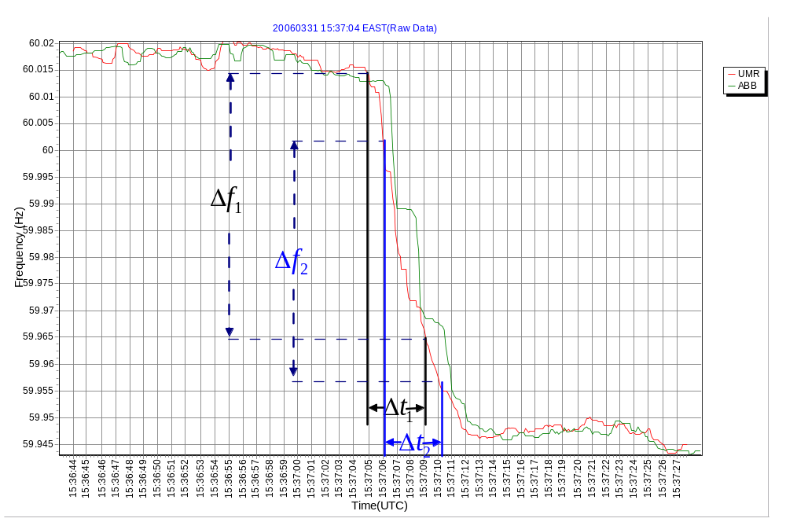

Fig 1. Frequency Excursion during an Event
Figure 1 is the plot of frequency excursion during an event. From our long term observation, the time for the transient process from the pre-event frequency to the post-event frequency is about 4 seconds. Therefore the 4 second is chosen as our calculation window. To prevent malfunction of the trigger module, double window criteria has been implemented. That is two separated calculation windows, which has 1 second interval, will be used in the algorithm, only if all of the two windows detect the event, the trigger will be asserted.

Before doing the calculation, the frequency data should be trimmed, which will eliminate the outliers in the frequency data. Here we will use the “vertical” and “horizontal” average to trim the frequency data. The “vertical” average means the average of the synchronized data from different measurements, while the “horizontal” average means the average along the time axis. Of course, all the measurements should from the same interconnection and the multiple units based algorithm will reduce the impact of data disruption from a single unit.

Implementation

Interface
'Class Definition
Public Class EventDetectTrigger
Inherits CalculatedMeasurementAdapterBase
#Region "Public Members"
'If an event detected, a public event will be raised up
Public Event EventDetected(ByVal eventTime As Long)
'Set up the initialization value for all the parameters.Like data rate, trigger criteria etc.
Public Overrides Sub Initialize(ByVal calculationName As String, ByVal_ configurationSection As String, ByVal outputMeasurements As_ IMeasurement(), ByVal inputMeasurementKeys As MeasurementKey(), ByVal_ minimumMeasurementsToUse As Integer, ByVal_ expectedMeasurementsPerSecond As Integer, ByVal lagTime As Double,_ ByVal leadTime As Double)
#End Region

'The function which will be called by other module to input the frequency data
Protected Overrides Sub PublishFrame(ByVal frame As _ TVA.Measurements.IFrame, ByVal index As Integer)

#Region "Private Members"
'The function checking the trigger threshold
Private Function checkEvent() As Boolean
'The frequency change rate threshold (Hz/Sec)
'The current seting: EI-0.005Hz/Sec, WECC-0.008Hz/Sec and
Can be changed in Initialize function
Private m_threshold As Double
'Time tick for most recent detected event
Private m_eventTime As Long
'Event type: generator trip or load trip
Private m_eventType As eventType
'Calculation window size (second), the default value is 4sec
Private m_windowSize As Integer
'The unCheck time interval between current time and the most
recent event time (second), preventing duplicate trigger
assertion for the same event
Private m_unCheckInterval As Integer
'The data pair of time and frequency
Private m_freqElement As freqElement
'The buffer for time and frequency
Private m_freqBuffer As ArrayList = New ArrayList()
'm_freqBuffer max capacity
Private m_maxCapacity As Integer
'PMU or FDR data Rate points/second, the default value is 30
points/second and it can be set in Initialization
Private m_dataRate As Integer
'MW/HZ ratio, the empirical algorithm for total trip amount=
Abs(pre-event freq – post-event freq)* (MW/HZ ratio)
Private m_MWHZRatio As Double
'Generator or load trip amount
Private m_tripAmount As Double
#End Region

Function Detail
Public Overrides Sub Initialize()
'pseudo code
Set m_windowSize
Set m_unCheckInterval
Set m_maxCapacity
Set m_dataRate
Set m_threshold
Set m_MWHZRatio
End Sub

Protected Overrides Sub PublishFrame()
'pseudo code
'Data condition for frequency data
Calculate Vertical_average
Calculate Horizontal_average
Push trimmed frequency data and time into m_freqBuffer
If timeinterval(most_current_tick – last_event_tick)> m_unCheckInterval
If checkEvent Then
RaiseEvent EventDetected(m_eventTime)
m_freqBuffer.Clear()
End If
End If
If m_freqBuffer.Count > m_maxCapacity Then
m_freqBuffer.RemoveAt(0)
End If
End Sub

Private Function checkEvent() As Boolean
'pseudo code
'The dfdt for the first window
DfDt1 = (deltaF1)/deltaT1
DfDt2 = (deltaF2)/deltaT2
If DfDt1 > m_threshold AndAlso DfDt2 > m_threshold Then
m_eventType = eventType.genTrip
m_eventTime = Event_timeTick
m_tripAmount = System.Math.Abs(deltaF1 * m_MWHZRatio)
Return True
ElseIf DfDt1 < -m_threshold AndAlso DfDt2 < -m_threshold Then
m_eventType = eventType.loadTrip
m_eventTime = Event_timeTick
m_tripAmount = System.Math.Abs(deltaF1 * m_MWHZRatio)
Return True
Else
Return False
End If
End Function

Flowchart

